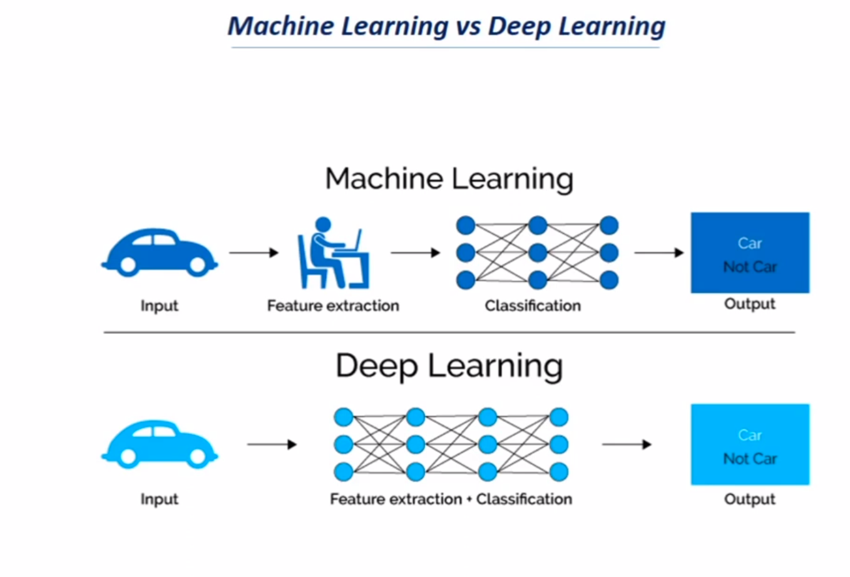
In ML we have to tell features about the input and also type of classification and then output is generated.

In DL feature+classification is handled by DL itself and Output is generated.

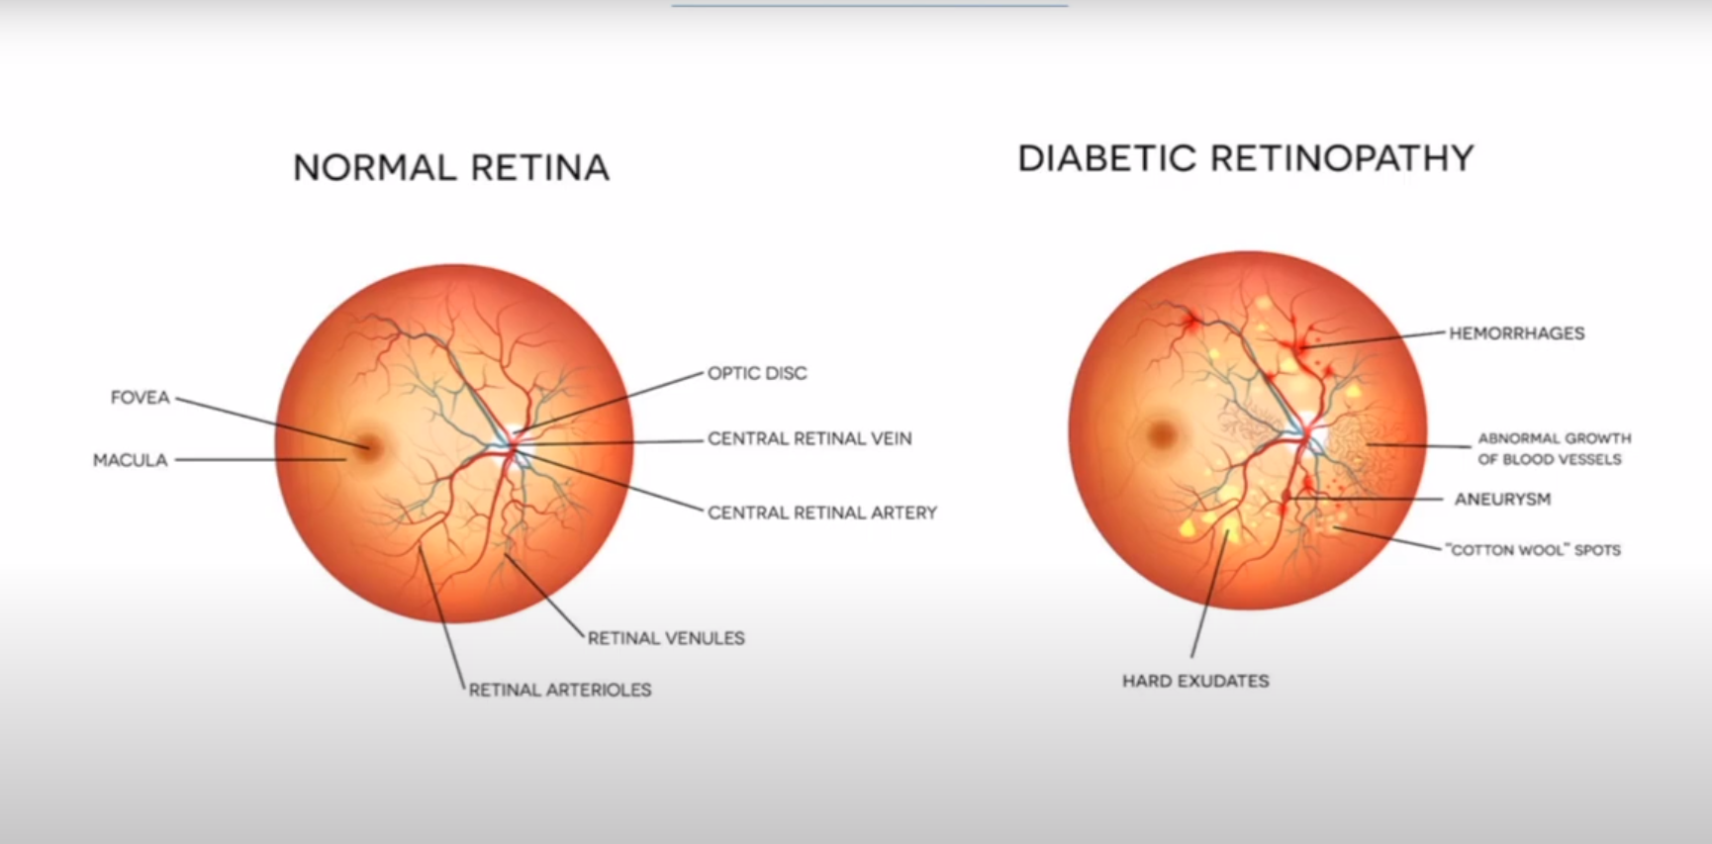
Usecase of DL if we provide dataset of normal eyes and we ask the DL to classify if we have diabetic retionpathy or not. It will tell not only that it will also tell about the gender,other diseases etc.

Applications of Deep Learning:
